HARVELELECTRIC ELECTRONIC STORE

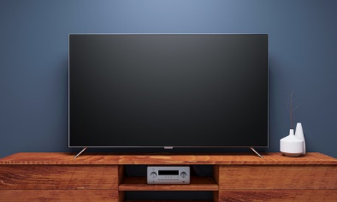

Itel 19" Inches A1940BE HD ELED TV (With High Voltage Protection)

Brand: [Itel](https://www.jumia.com.ng/itel/)

**Price: $3760**

Was ~~$4000~~ 54%

+ shipping only for V.V.I.P clients.

## **Product details**

If you are looking for a **19 inches HD ELED TV**that is similar in size and screen quality of a 22 inches HD ELED TV, then Itel 19 inches HD ELED TV is your best bet. It has an in-built protection against high current or voltage  and it's double glass screen provides double protection against screen damage. The fact that it has double glass might give you a concern about how bright it would be. Don't worry, that was taken care off during its production. The screen is far brighter than TVs without extra protection. In fact, its super bright!

It has beautiful games you and or your kids can play to relax and or bond together as a family. This TV can be used on Direct current (DC) or Alternating Current (DC) unlike other TVs which are mostly used on only DC.

Warranty Period is 12 months.

## **Specifications**

## **KEY FEATURES**

* Overvoltage Protection
* Built-in 5 Games
* Double glass
* LED Module
* Plastic Body
* Powerful CPU
* Simplified UI &OSD Design
* Enjoy Videos/MP3/Pictures through USB Flash
* Super Picture Quality (HD 1440*900)
* Excellent Sound Quality (Built in 2 pcs 5W Speaker)

## **WHAT’S IN THE BOX**

1. Itel 19" Inches HD ELED TV set
2. Manual
3. Stand and screw
4. Remote control
5. Batteries

Power cord and 13amps plug

## **SPECIFICATIONS**

* **SKU**: IT724EA0IK55JNAFAMZ
* **Product Line**: Itel Official Store
* **Model**: Itel A1940BE
* **Production Country**: China
* **Size (L x W x H cm)**: 57.3 x 9.8 x41.8 cm
* **Weight (kg)**: 4.6
* **Color**: Black
* **Shop Type**: Harvel Electric Store